**DRONACHARYA**

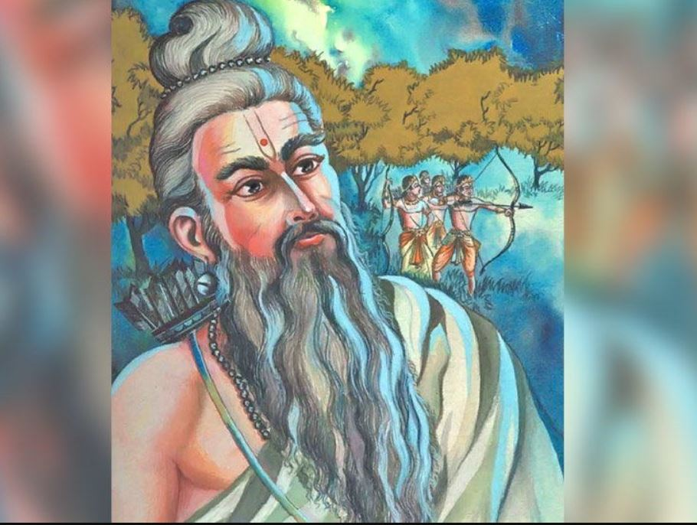

In the epic [Mahabharata](https://en.wikipedia.org/wiki/Mahabharata" \o "Mahabharata), **Droṇa** ([Sanskrit](https://en.wikipedia.org/wiki/Sanskrit_language" \o "Sanskrit language): द्रोण, *Droṇa*) or **Droṇāchārya** or **Guru Droṇa** or **Rajaguru Devadroṇa** was royal [preceptor](https://en.wikipedia.org/wiki/Preceptor" \o "Preceptor) to the [Kauravas](https://en.wikipedia.org/wiki/Kauravas" \o "Kauravas) and [Pandavas](https://en.wikipedia.org/wiki/Pandavas" \o "Pandavas). He was a friend of [Guru Sukracharya](https://en.wikipedia.org/wiki/Guru_Sukracharya" \o "Guru Sukracharya), the [guru](https://en.wikipedia.org/wiki/Guru) of [Asuras](https://en.wikipedia.org/wiki/Asura), including [Mahabali](https://en.wikipedia.org/wiki/Mahabali" \o "Mahabali). He was the son of rishi [Bharadwaja](https://en.wikipedia.org/wiki/Bharadwaja" \o "Bharadwaja) and a descendant of sage [Angirasa](https://en.wikipedia.org/wiki/Angiras_(sage)" \o "Angiras (sage)). He was a master of advanced military arts, including the divine weapons or [Astras](https://en.wikipedia.org/wiki/Astra_(weapon)" \o "Astra (weapon)). He was also the second commander- in- chief of kaurava army from 11th day to 15th day. He failed 4 times in capturing Yudhisthira (11th, 12th day, 14th day when [Arjuna](https://en.wikipedia.org/wiki/Arjuna" \o "Arjuna) was busy fighting to kill [Jaydratha](https://en.wikipedia.org/wiki/Jayadratha" \o "Jayadratha) and 14th night. He was beheaded by [Dhrishtadyumna](https://en.wikipedia.org/wiki/Dhrishtadyumna" \o "Asura) when he was meditating to release his soul on the battlefield.

**Birth**

Drona is regarded as the first test tube baby (theoretical). There was a rishi named Bharadwaja. One day, Bharadwaja went to the Ganga River to bathe as part of the Agnihotra yagna. At the banks of the river, he saw the Apsara (celestial nymph) Ghritachi. As she emerged from the river, Bharadwaja became lustful.

Because of this, his vital fluid came out. He swiftly caught it in a wooden vessel called a “**drona**“. Soon, a boy was born from the vessel. Bharadwaja named him Drona after the vessel he was born in.

**Friendship of Drona and Drupada**

Drona grew up at his father’s hermitage on the banks of the Ganga. He studied the Vedas and the other scriptures. He learned the knowledge of celestial weapons, such as the “Agneyastra” and “Brahmastra”, from Agnivesha Rishi. Bharadwaja Rishi was dear friends with King Prishata of Panchala. Around the time of Drona’s birth, Prishata had a son named Drupada. Prishata’s son used to come over everyday to play and study with Drona. Drupada used to say, “Drona, when I obtain my father’s kingdom, it will be yours. All of my wealth and power will also be your wealth and power!”

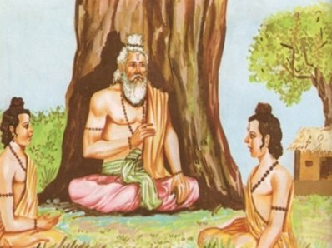

As time passed, Drona and Drupada parted ways. Drupada succeeded his father as the king of Panchala. Meanwhile, Drona mastered the Vedas and married Kripi, the daughter of Saradwata Rishi. Soon, Kripi gave birth to a boy. A celestial voice said, “When this boy was born, he neighed like a horse. Thus, he will be named Ashwatthama (the horse-voiced)!” Drona was overjoyed with the birth of his son.

## Drupada’s Betrayal

Drona and his family were very poor. One day, Ashwatthama saw some rich kids drinking milk. He began to cry because his family could never afford milk. Drona was saddened upon seeing this sight. He went looking for a cow, but couldn’t find one.

Once, Ashwatthama’s friends gave him water mixed with powdered rice and told him it was milk. Ashwatthama eagerly drank it and started excitedly shouting, “I am drinking milk!” Ashwatthama’s friends began to giggle. Drona couldn’t bear seeing this.

He decided to approach his childhood friend Drupada for wealth. After all, Drupada was a rich king. Drona presented himself in Drupada’s court and said, “Remember me, Drupada. I am Drona, your friend.”

But Drupada had grown arrogant because of his prosperity and power. He retorted, “You are so dull, Brahmin. It is true that we used to be friends before. But that was because we were equal. Now, I am a great, wealthy, and mighty king. Meanwhile, you are a poor, cowardly beggar. I am strong and learned, while you are wek and foolish. How I can be friends with you!“

Drona was enraged. He vowed to take **revenge** for this insult.

**His role in Mahabharata :**

### **Story of the Ball in the Well**

Once, the Pandavas and Kauravas were playing with a wooden ball outside. The ball accidentally landed into a nearby empty well. All of the princes tried to take it out, but it was too deep. At that moment, Drona strolled past them. He watched them and chuckled. He then said, “Shame on you princes! You are the descendants of King Bharata, but you can’t retrieve this ball. Watch, I will take it out with a chain of grass.”

Saying that, Drona threw a blade of grass at the ball and pierced it. He then pierced the blade of grass with another blade of grass and continued until a chain was formed. Using the chain, he easily removed the ball.

The princes were astonished by this impossible feat. “We have never seen this skill anywhere. You are truly great. What can we do for you?” they lauded.

“Tell Bhishma about my skill. He will definitely recognize who I am,” Drona instructed. Accordingly, the princes informed Bhishma about what had happened. Bhishma immediately knew that this was none other than Drona. He personally visited Drona, who told him about everything that had happened.

Bhishma said, “Oh Brahmin, make the Kuru princes skilled in the use of arms. I want you to be their teacher. I am truly grateful that you are teaching the princes.” Drona readily accepted Bhishma’s offer.

**His Favorite Student**

Bhishma gifted Drona with a house and a lot of wealth. Thereafter, the Pandavas and Kauravas began learning from Drona. They called him “Dronacharya” (acharya means teacher).

One day, Dronacharya called all the princes and said, “I have a motive in my heart. Promise me that once you become skilled with weapons, you will accomplish this motive for me.”

Silence. Utter Silence. Not one of the princes said a word. **But then suddenly, [the Pandava Arjuna](https://glorioushinduism.com/2016/10/16/arjuna/) stepped up and vowed that he would accomplish this motive, no matter what it is.** Dronacharya started shedding tears of happiness. From that day, Arjuna became Drona’s favorite. As you will see, Arjuna would continue pleasing Drona.

Drona began teaching the princes the use of various weapons. Many other princes from across Bharatvarsha flocked to learn from Drona. The Vrishnis, Andhakas, and even [Karna, the son of Adhiratha Suta,](https://glorioushinduism.com/2017/04/30/karna/) began learning from Drona.

From all of these princes, Arjuna was clearly the BEST at the use of weapons. Drona loved Arjuna, but he also loved him son Ashwatthama. Hence, whenever Drona would send his pupils to fetch water, he would give them a narrow-mouthed vessel. But he gave his son Ashwatthama a wide-mouthed vessel. Ashwatthama was thus able to fill his vessel faster and quickly return to his father. In these little intervals, Drona would teach his son about celestial weapons. When Arjuna learned of this, he started quickly filling his vessel using the Varunastra weapon to summon water. He would return at the same time as Ashwatthama and receive the same lessons.

Arjuna’s devotion to his guru and the science of arms quickly made him Drona’s favorite. Once, while Arjuna was eating dinner, a strong breeze blew out the lamps. But Arjuna kept eating in the darkness. At that moment, Arjuna realized that through habit, he could master archery in the darkness as well. Thus, Arjuna began practicing archery at midnight.

When Drona heard the twang of the bow, he approached Arjuna and said : *I give you a promise that you shall become and remain the greatest archer in the world !*

Drona then started teaching Arjuna how to fight on horseback, on an elephant, on a chariot, and on the ground. Arjuna was taught how to use a sword, javelin, lance, mace, and the dart.

### **Ekalavya cuts off his right thumb**

One day, the Pandavas and Kauravas went on a hunting excursion with Drona’s permission. A servant with a dog followed the princes. The dog got separated from its owner and wandered into the woods. Suddenly, the dog encountered an adolescent and began loudly barking.

The adolescent quickly sent seven arrows into the mouth of the dog, which stopped it from barking. The dog ran back to the hunting party. When the Pandavas saw what had been done to the dog, they were filled with wonder and awe. Who was this impeccable archer? How could he do this without killing the dog?

The Pandavas started searching the woods. In time, the Pandavas came across the boy dexterously discharging arrows from his hunting bow. When the Pandavas asked him who he was, he replied, “I am Ekalavya, son of King Hiranyadhanus of the Nishadhas. I am a pupil of Guru Drona. **I was rejected by Drona, but I was determined to master archery. So I made a clay statue of Drona and practiced in front of it. Soon, I mastered archery**.”

The Pandavas conversed with Ekalavya and then returned to Drona’s hermitage. The Pandavas told him about Ekalavya. Drona regretted having rejected Ekalavya. But while the other Pandavas were excitedly discussing his feats, Arjuna was in deep thought…

After the others left, Arjuna went up to Drona and expressed his thoughts: “Earlier, you had promised me that I would be your greatest pupil. Why then is Ekalavya superior to me?”

Drona painfully reflected for a moment. Realizing what had to be done, Drona, accompanied by Arjuna, went to meet Ekalavya. Drona said, “Ekalavya, if you are truly my pupil, then you must give me gurudakshina *(*repaying one’s teacher after education).”

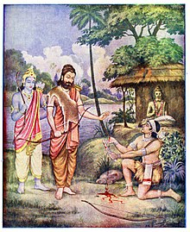Ekalavya responded, “Guruji, I am grateful to have the opportunity to give you something. Ask for anything, and I shall give it.”

“**Well then, give me your right thumb**,” Drona demanded. Drona knew that without his right thumb, Ekalavya would never be as good as before. Arjuna would be able to surpass him in archery skills. **Without hesitation, Ekalavya cut off his right thumb.** Drona, who felt ashamed, and Arjuna, who’s jealousy was cured, departed. Ekalavya would continue practicing archery, but he would never be as good as before…

### **Karna Asks for the Brahma Weapon**

Seeing Arjuna receive the Brahmashira Astra, Karna approached Drona and requested, “I too want to learn the knowledge of the Brahmastra weapon. Please give it to me.” However, Drona knew that Karna was associating with the wicked Duryodhana. He also favored Arjuna. Thus, he said, “Only worthy Kshatriyas and Brahmins can receive the Brahmastra. I cannot give it to you.” Karna was extremely disheartened and left to go to Parshuram.

### **Drona's Revenge**

After Drona completed the formal training of the Kuru princes, he demanded that they invade Panchala and bring him Drupada as their Gurudakshina. Arjuna succeeds in defeating Drupada and brings the captured king to Drona. Drona reminds Drupada about their days of friendship and his false promise before taking away half of the Panchala kingdom.[[9]](https://en.wikipedia.org/wiki/Drona" \l "cite_note-9) Drona would make Ashwatthama the king of the annexed half of the Panchala kingdom. This action would lead Drupada to perform a sacrificial yagna in order to beget a son who would kill Drona. The sages Upayaja and Yaja helped him to beget such a son Dhrishtadyumna. The sacrificial fire also yielded a woman, Draupadi

## Kurukshetra War and Death

After the Pandavas’ exile, war was declared between the Pandavas and Kauravas. Drona joined the Kauravas because it was his duty to fight for the Kuru clan. Ashwatthama, being a friend of Duryodhana, also joined the Kauravas.

In the Kurukshetra war, Drona annihilated many Pandava armies and kings/princes. On the tenth night, after the defeat of Bhishma, the Pandavas needed a knew commander-in-chief. Karna suggested that Drona should become the next commander-in-chief, saying that he is the oldest and most experienced. Drona was honored and asked Duryodhana to ask for anything he wanted. Duryodhana said that he wanted Drona to capture Yudhistira. Drona agreed and promised Duryodhana that he would capture Yudhistira.

On the 11th day, Drona was unstoppable. He defeated Dhristadyumna, Abhimanyu, Bhima, Nakula, Sahadeva and even killed a few young princes from the family of Drupada. As Drona kept getting closer to Yudhistira, the Pandava forces started panicking. Arjuna heard this panic and approached Drona. Duryodhana ordered thousands of chariot fighters to attack Arjuna, but Arjuna killed them all. Arjuna didn’t let Drona get to Yudhistira. That night, Duryodhana ridiculed Drona so much for failing.

On the twelfth day, Susharma made a vow that he would fight Arjuna and distract him so that Drona could capture Arjuna. When the war began on that day, Drona was in rage. He first engaged Satyaki, who, aided by Pandava forces, defeated Drona. Drona then regained his composure and started attacking Panchala forces, killing two more princes from the family of Drupada. Drona then single-handedly defeated Satyaki, Chekitana, Dhristadyumna, and Shikhandi. Then Bhima challenged Dronacharya. Bhima, aided by Dhristadyumna and Satyaki, was able to defeat Dronacharya. Drona then fought Arjuna, Dhristadyumna, Satyaki, and Abhimanyu.

That night, Duryodhana was enraged at Dronacharya. He had now failed twice. Dronacharya started losing his patience as Duryodhana mocked him. “Oh Duryodhana. Yudhistira knows we are trying to capture him. It is now really difficult as he is well-guarded. But I will try my best. Tomorrow, I will form the Chakravyuha. Arjuna will be led away by Susharma and his army. Only Arjuna knows how to penetrate this formations. One of the Pandava heroes will surely get trapped and killed.”

On the thirteenth day, Dronacharya formed the Chakravyuha. Arjuna was already far away from the battlefield. The warrior who entered the battlefield was Abhimanyu, followed closely by the 4 Pandavas. But Jayadratha cut off the Pandavas’ entrance to the Chakravyuha. He had a boon from Lord Shiva that one day in his life, he won’t be defeated by anybody. Today was that day, so the Pandavas couldn’t do anything. Abhimanyu proceeded into the Chakravyuha alone. Abhimanyu knew how to enter the Chkravyuha, but not how to exit it. Because of this, he got trapped in the middle with all the main Kuru warriors. Abhimanyu killed many kings on the Kuru side and caused a lot of havoc. But in the end, multiple warriors attacked him on all sides and he was killed by Durjaya, the son of Dushasana.

That night, Arjuna made a vow that he would kill Jayadratha. On the fourteenth day, Drona formed the Shakata Vyuha to protect Jayadratha. Even though the vyuha was miles long and Jayadratha was at the far end, Arjuna was unstoppable. He killed countless princes and kings on the Kaurava side. Soon, he reached Dronacharya. Drona and Arjuna kept fighting and it didn’t look like anyone was defeating the other. Arjuna soon realized this and told Krishna to leave Drona and move forward. When Krishna did so, Drona started following Arjuna’s chariot. But Dhristaketu from Chedi stood in the way of Drona and Arjuna. With a roar, Dhristaketu challenged Drona. They fiercely fought but in the end, Drona fired the Anjalikastra and killed Dhristaketu. But Dhristaketu had bought Arjuna time to get away from Drona.

Dronacharya then attacked Dhristadyumna and killed many Panchala princes. After a fierce fight, Drona was about to kill Dhristadyumna when Satyaki intervened. Satyaki was able to keep Drona at bay. Meanwhile, Yudhistira worried that Arjuna might need help, so he sent Satyaki. When Satyaki reached Drona, he just evaded him because he knew he couldn’t defeat Drona. Yudhistira then sent Bhima to help Arjuna and Satyaki. Bhima destroyed Drona’s chariot eight times. In the end, Drona and the Kuru warriors tried their best, but Arjuna killed Jayadratha before sunset. That night, the battle continued after sunset and in the night battle, Ghatotgacha was killed.

On the fifteenth day, Drona destroyed more of the Panchala forces and killed King Sibi. Drona then engaged Satyaki, Bhima, and Dhristadyumna. He then encountered and killed his old friend, Drupada. After that, he killed King Virata of Matsya. Seeing his father dead, Dhristadyumna was enraged and charged at Drona. But Duryodhana, Karna, and Shakuni formed a protective circle around Drona. Soon, Arjuna and Bhima arrived there. A fearsome fight ensued between Arjuna and Drona. They both kept firing at each other and every arrow was countered.

Knowing he can’t win against Arjuna, Drona left him alone and starting destroying the Panchala army. As he remembered the way Duryodhana had insulted him over the past few days, he grew more and more raged and attacked with more ferocity. Soon, he started using celestial weapons on the soldiers, which was forbidden by the rules of war, but Drona didn’t care right now.

Yudhistira became worried as he saw Drona destroying his armies. He went to Krishna for advice. “Oh king, Drona is going to continue to slaughter our armies. If he continues like this, there will be no army by this evening. The only way to kill him is to make him drop his weapons,” Krishna said.

“And the only way to make him drop his weapons is to kill Ashwastamma. If he thinks Ashwastamma is dead, he will lose hope and quit fighting. Dhristadyumna can then kill him,” Krishna continued.

“But you can’t kill Ashwastamma. He is a Chiranjivi (immortal),” Arjuna said.

“We don’t have to kill the guru’s son Ashwastamma. There is another Ashwastamma, the elephant. Bhima can kill that elephant and then we can cry out that Ashwastamma is dead,” Krishna said.

Arjuna and Yudhistira were shocked and didn’t like deceiving their guru, but they knew they had no other option. Bhima immediately went and found that elephant. He killed the elephant and its rider, Indravarma, the ruler of Malva. Bhima then went around screaming that Ashwastamma was dead. Drona’s limbs seemed to dissolve, but then he remembered his son’s prowess and realize Bhima was lying. Drona again started fighting vigorously and released the Brahmastra on Pandava forces. Seeing this, Bharadwaja, Vashishta, Gautama, Kashyapa and many other holy sage along with Agni appeared in the sky and told Drona that he was not obeying the rules of war. They also told him that his end was soon to come. Drona said that he had taken a vow to destroy the Pandava army and since so many rules had been broken already, there was no point.

Bhima then came to Dronacharya and said, “Oh Brahmin, what are you doing. You should be offering austerities and doing penance. But instead you are here, massacring soldiers, and that too unfairly. You should be ashamed. Your son is dead, and you keep fighting.”

Drona was struck by these words. He started second-guessing his decision that Ashwastamma isn’t dead. Drona dropped in his chariot. He remembered the words of the sages and of Bhima. What if Ashwastamma was actually dead? He looked around and saw Dhristadyumna fighting nearby. Maybe it was time for his death? To be sure of Ashwastamma’s death, there was only one person who wouldn’t lie: Yudhistira. Krishna saw Drona coming near Yudhistira and said, “Oh Yudhistira, look, Dronacharya is coming to ask you. Please save us from the wrath of Drona and just tell him Ashwastamma is dead. According to the scriptures, it’s okay to lie in certain situations.” Reluctantly, Yudhistira told Dronacharya, “Ashwastamma is dead.” Then he whispered, “Whether the elephant or man, I know not.” Drona was heartbroken. He dropped his weapons and sank into grief.

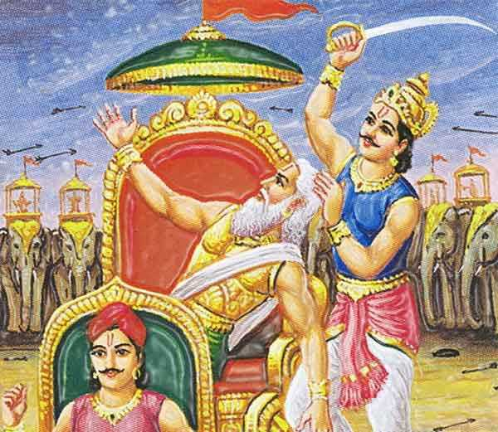

Dhristadyumna now attacked Dronacharya. Drona weakly picked up his bow and started firing back. He tried invoking celestial weapons, but they didn’t appear. Soon, his inexhaustible quiver of arrows ran out of arrows and Drona realized he is supposed to die now. He lay down his bow and repeatedly cried out Ashwastamma’s name. He then said, “Duryodhana, Karna, Kripacharya. Fight with prowess. I am now departing this Earth.” Saying so, Drona sat down in his chariot in a meditative posture and made his soul leave his mortal body. Not knowing Drona was already dead, Dhristadyumna ran up to him and beheaded him. Arjuna and Yudhistira were deeply saddened by the deceitful killing of Drona.